Aryan Sai Venkat M

230701040 CSE A

EXP NO:3a Shell Script –Reverse the Digit

# PROGRAM

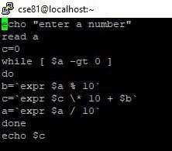

# OUTPUT

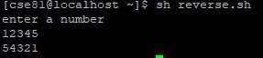

EXP NO:3b Fibbonacci Series

# PROGRAM

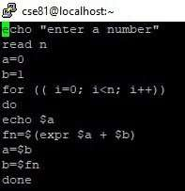

# OUTPUT

1

